**Appendix 2**

**Waroona-Yarloop Bushfires**

In January 2016, a lightning strike triggered a blaze that tore through some of WA's best agricultural land, near Waroona south of Perth.

By the time it was extinguished 17 days later, almost 100,000 hectares of land had been scorched, 181 homes and buildings destroyed and two lives had been lost.

The Map below show the extent of the bush fire.

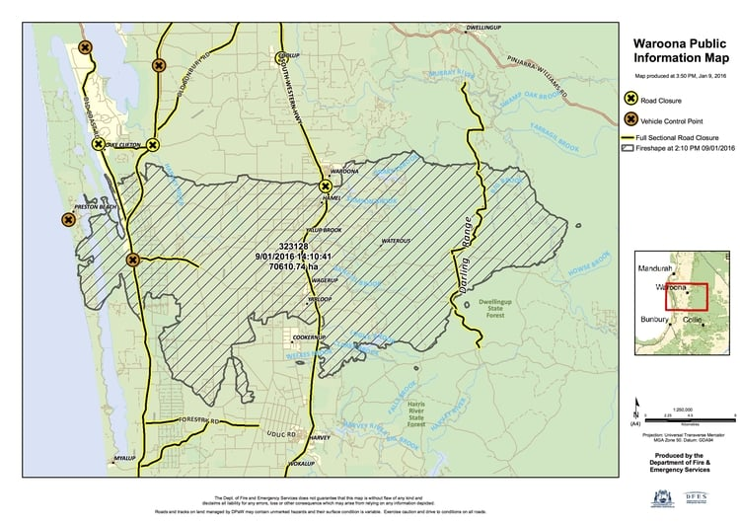

"We've all had different traumas through our lives, but that was a big one," said beef farmer Mike Walmsley, who fought tooth and nail to stop the flames flattening his 250 hectare property. "It was like nothing we'd ever seen before. The noise … it was like a jet plane." For many of the region's farmers who rely on the land for income, life has not been the same since. "The soil is basically sterilised from the heat," Mr Walmsley said. "Any seeds that were in there would be basically cooked — there's not a lot of organic matter left in that. "This could look like this for some years to come. I'd say decades." Aid groups have been concerned about the mental wellbeing of some of the farmers since the blaze. The Shire of Waroona has secured funds for an outreach program through the Australian Red Cross and volunteers are in the process of visiting every farmer in the district to find out how they are coping.

**Part 2**

A key quokka population on the West Australian mainland decimated by a bushfire has started to recover, with recent surveys finding numbers have surged. The 2016 Northcliffe fire in the state's south-west destroyed 100,000 hectares (1000km2) of forest and its estimated quokka numbers dropped from 500 to just 39. The species is listed as vulnerable and has been in a steady decline over the past decades, but surveys by World Wildlife Fund and the WA Department of Biodiversity, Conservation and Attractions have found quokkas have returned to the fire-ravaged area. "We've just repeated the surveys that we did in the first year following the fires so across 126 sites," Species Conservation Manager for WWF Australia Merril Halley said. "Now we can estimate that there's at least over 300 individuals across the north-west fire area which is fantastic."

While not all quokkas have returned to all of the fire affected bushland, Ms Halley said the signs are promising. "I think it's good news, given the extent of the fire and the severity of the fire, that quokkas have been able to recolonise the area really quickly," she said. Baiting and remote sensor cameras have been installed to help protect the marsupials from predators. "The department has done extra baiting after the fire, so they are continuing to do that," Ms Halley said.

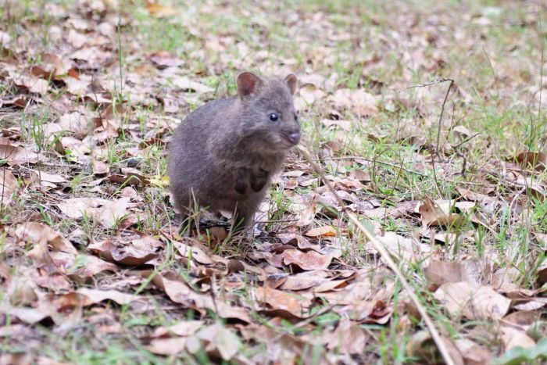**Every quokka is precious**

During the March surveying period a baby quokka was found abandoned by its mother and is currently being rehabilitated at the Maroo Wildlife Refuge, east of Manjimup. Glen Burston, who co-founded the refuge, said 'Averil' will be cared for until she can be released. "Because of the low populations that are down there now it's the upmost important that she does go back into the wild," he said. "She's a breeding female and she'll be at breeding age when she is released, so it's imperative to get those numbers back up to where they were prior to 2015."

**The Forgotten Quokka**

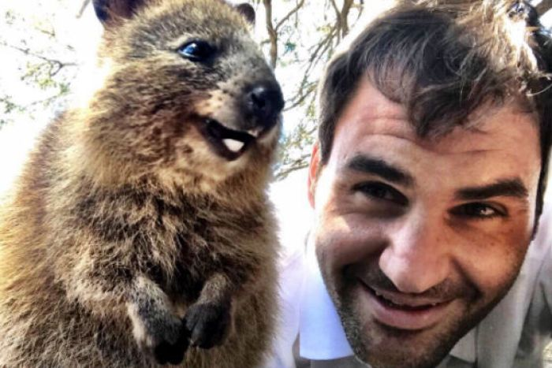This population surge in Northcliffe is in stark contrast to the overall declining quokka population, but Mr Burston said most people are not even aware quokkas are found on mainland WA. Quokkas are famous on tourist hotspot Rottnest Island, with a recent 'selfie' of tennis star Roger Federer and a quokka seen by more than 500 million people on social media site Instagram. The quokkas are the same species as their mainland cousins, but have adapted to tourists, by feeding during the day and allowing humans to get close enough for a photo. Ms Halley said it is hard to care about the mainland nocturnal quokka if people do not even know they exist. "The mainland quokkas are really important, and they've disappeared from over 50 per cent of their range," she said. "People not only don't know they're here, but they don't know that we've seen a huge decline in quokkas because of habitat and because of predators. "They are actually a lot more genetically diverse than the Rottnest quokka, even though they are quite likeable for their selfie opportunities."

The pictures below show the Waroona area just after the fires and the two subsequent photos taken a few months later and almost a year later.

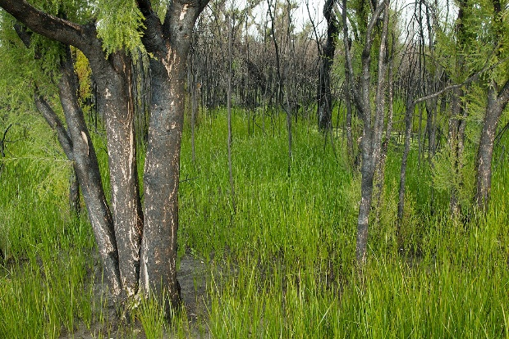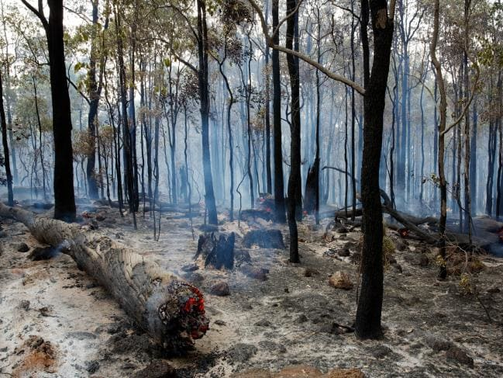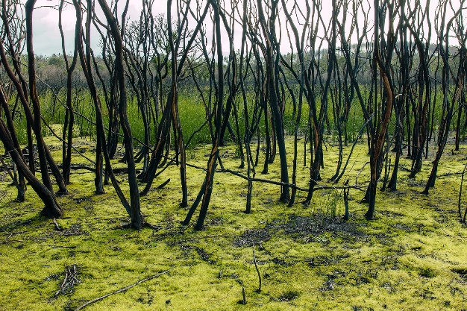

1. Name the three levels of biodiversity and describe the impact that the bushfire would have had on each level.

_______________________________________________________________________________________________________________________________________________________________________________________________________________________________________________________________________________________________________________________________________________________________________________________________________________________________________________________________________________________________________________________________________________________________________________________________________________________________________________________________________________________________________________________________________________________________________________________________________________________________________________________________________________________

1. When examining the images of the Waroona fire at the end of the reading two different comparisons are being made. What are the two types of comparisons that biologists can make?

_______________________________________________________________________________________________

1. After a catastrophic event like the Waroona fires ecological succession will occur. Name the two types of ecological succession and explain how they are different.

___________________________________________________________________________________________________________________________________________________________________________________________________________________________________________________________________________________________________________________________________________________________________________________________________________________________________________________________________________________________

1. The middle photo at the end of the article show the beginnings of ecological succession. What is the name given the type of species that are first to appear after a niche has been emptied and describe the generic features that these species would have.

__________________________________________________________________________________________________________________________________________________________________________________________________________________________________________________________________________________________________________________________________________________________________________________________________________________________________________________________________________________________________________________________________________________________________________________________

1. The bushfire had a big impact of the carbon cycle in that area of bushland. Describe how the bushfire would have affected the processes that move carbon through the ecosystem.

__________________________________________________________________________________________________________________________________________________________________________________________________________________________________________________________________________________________________________________________________________________________________________________________________________________________________________________________________________________________________________________________________________________________________________________________

1. From the reading, what methods are being used to monitor the quokkas?

_______________________________________________________________________________________________

1. Write the formula for capture-re-capture.

_______________________________________________________________________________________________

1. When using capture-re-capture what are the 6 assumptions that are made?

_________________________________________________________________________________________________________________________________________________________________________________________________________________________________________________________________________________________________________________________________________________________________________________________________________________________________________________________________________________________________________________________________________________________________________________________________________________________________________________________________________________________

1. When looking at the quokkas what are four features of the population that can be used to describe them?

___________________________________________________________________________________________________________________________________________________________________________________________________________________________________________________________________________________________________________________________________________________________________________________________________________________________________________________________________________________________

1. Determine the abundance of the quakkas in the Waroona area before and after the fire.

_____________________________________________________________________________________________________________________________________________________________________________________________________________________________________________________________________________________________

1. Fires are an important part of Australian ecosystems, in particular many Australian ecosystems depend on fire regimes. The impact that a fire regime has are affected by three factors, what are they and how do they affect the impact of the fire regime?

___________________________________________________________________________________________________________________________________________________________________________________________________________________________________________________________________________________________________________________________________________________________________________________________________________________________________________________________________________________________